**Resume**

**Personal Information**

**Mr. Alex C. Verlek - van Tienhoven CPCC, PCC  
Verlek Coaching Works**

Kerkbuurt 140

3354 XM PAPENDRECHT  
The Netherlands

Office Phone + 31 (0)78 - 642 54 68

Cell Phone +31 (0)6 - 304 19 121

info@coaching-works.nl

Date of Birth : 17-08-1964

Nationality : Dutch  
Social Security # : 11 17 98 085  
Marital Status : Married

**I am**

Before trying to ‘impress’ you with diploma’s and working experience, let me tell you who I am. To me, that’s (at least) equally interesting.

I am a people person, focused on relationships and details.  
I am quick and often taking the initiative. Always doing things.  
At the same time I’m able to listen, to care for people.  
In the Leadership Program I’ve been typed as eccentric.  
I am enthusiastic and eager to learn, frequently exploring new challenges.  
I’m ready to take a risk and experiment. I encourage other people to expend their possibilities.

I am the one who can take a decision when that’s needed. Justice and my instinct very often lead me.

I am able to enjoy small things.  
I am the one taking the initiative to celebrate successes, my own or someone else’s.  
I am a perfectionist, and I know I’m not perfect! Sometimes inpatient and too fast.   
I am a Christian and also know my challenges and weaknesses. I prefer to look at ‘the speck in my own eye’…

I enjoy life!  
I am happy with who I am. And I know there is more to explore. I am on a journey…

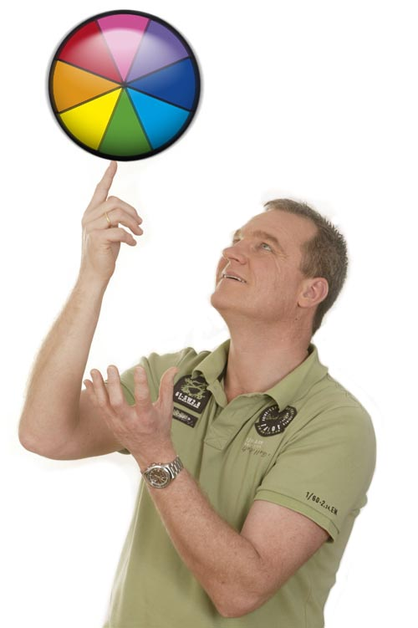

**Education / Qualifications**

Education / Institute **Coaches Training Institute**

Specialization Leadership Program (Spain)

Start October 2009

Certificate June 2010

Education / Institute **Coaches Training Institute**

Specialization CPCC (Certified Professional Co-Active Coach)

Start 2008

Certificate June 2009

Education / Institute **Schouten & Nelissen**

Specialization Co-Active Coaching

Start 2007

Certificate December 2007

Education / Institute **Schouten & Nelissen**

Specialization Pre-module Psychology

Start 2007

Certificate June 2007

Education / Institute **ISBW/Schouten & Nelissen**

Specialization RET Basic (Rational Emotive Therapy)

Start 2007

Certificate October 2007

Education / Institute **VOA / Storck-Marcad**

Specialization Management Science

Start 1992

Certificate June 1994

Education / Institute **Hogeschool Haarlem**

Specialization HRM (HBO AP/PB)

Start 1988

Certificate June 1990

Education / Institute **Hogeschool Haarlem**

Specialization HRM (MBO-AP/PB)

Start 1985

Certificate June 1988

**Languages** Dutch and English (fluent), German (rather well) and a little bit of French

**Working Experience**

2011 - present Organization **Coaches Training Institute (CTI) (free lancer)**

Position Front of Room Leader coaches training (in English)  
Location International

11-2007 - present Organization **Verlek Coaching Works (zzp)**

Position Coach/trainer/consultant (owner)  
 Location Papendrecht / International

10-2001 - 12-2007 Organization **Albert Schweitzer Hospital**

Position HRM specialist / Project manager / Coach

Location Dordrecht

8-1994 - present Organization **The Music Works**

Position Project manager / promoter (owner)

Location Papendrecht / International

10-1990 - 8-1996 Organization **SMRA**

Position HRM specialist / Software- & Production manager

Location Delft

9-1983 - 12-1984 Organization **Ministry of Defense**

Position Sergeant (National Service)

8-1980 - 9-1990 Organization **National Post (PTT)**

Position Counter-clerk / junior HRM-officer

Location Rotterdam area